LAB Logbook

Lab 1

Lab 2

Test Accuracy: 0.862

Lab 3

Test accuracy: 0.8924999833106995

Lab 4

absolute prediction error = 54302.0 $

relative prediction error = 24.47138350608382 %

Lab 5

The Optimal Number of Epochs for training my model: 15

Minimum validation loss : 0.9141

Lab 6

Minimum Validation Loss: 0.0014

The Optimal Number of Epochs for training my model: 7

Lab 7

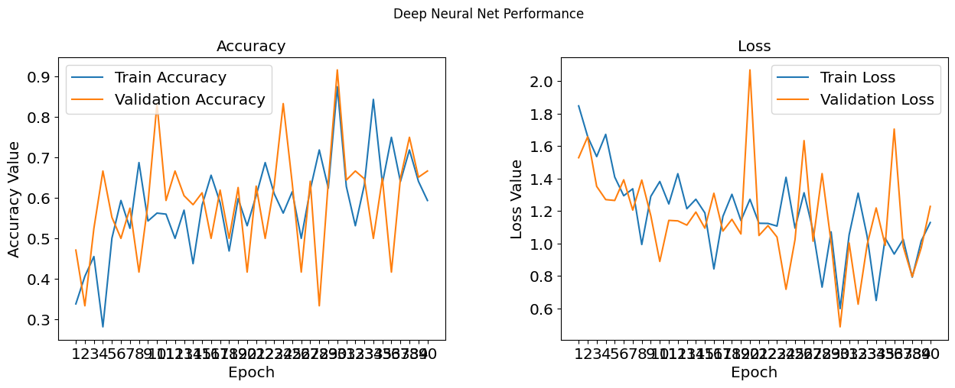

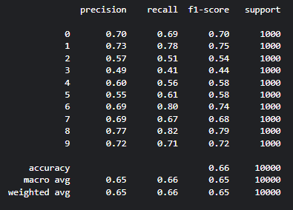

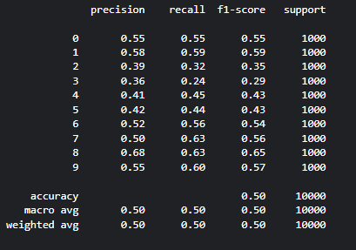

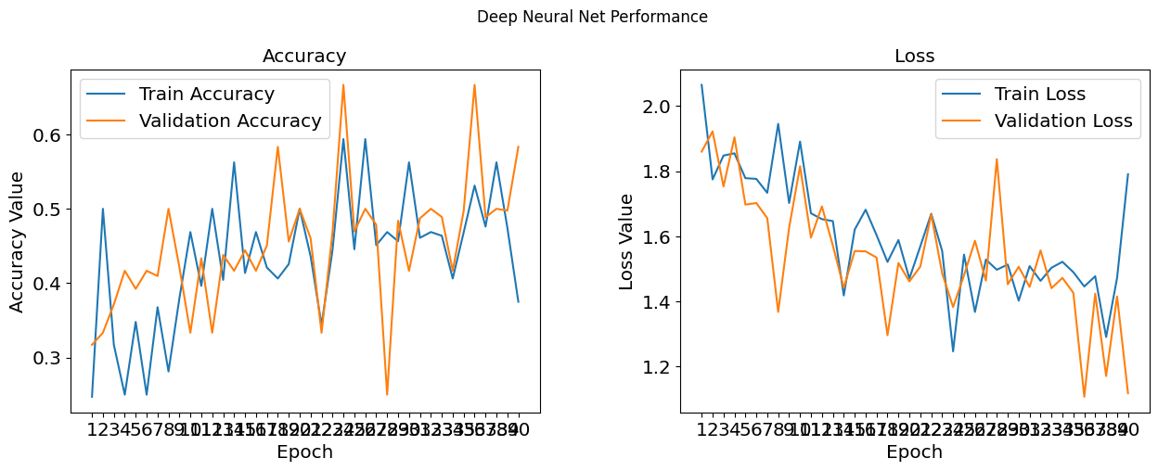

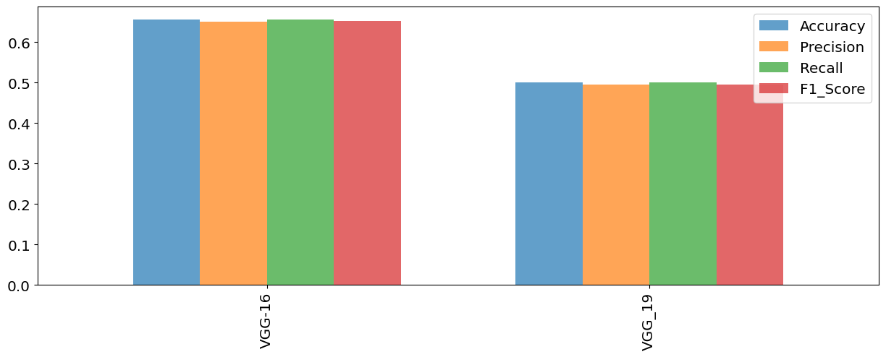

Lab 8

LSTM Architecture

Code Training and Result

Lab 9

Early Stopping and Modal Check Points functions



Test Accuracy and Error Metrics

Accuracy Graph

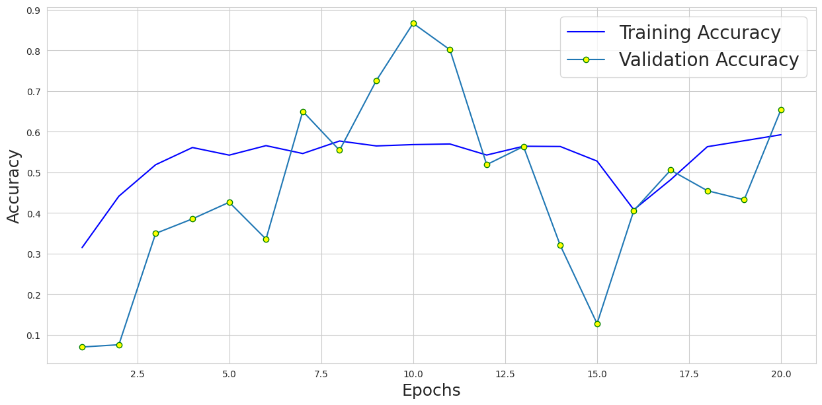

Lab 10

Simple AutoEncoder

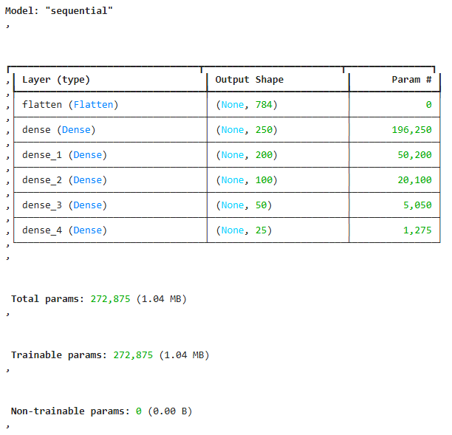

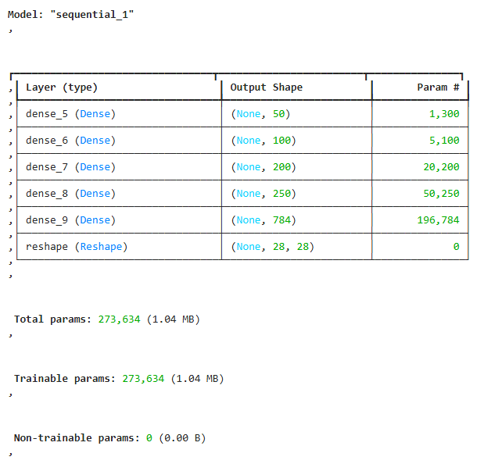

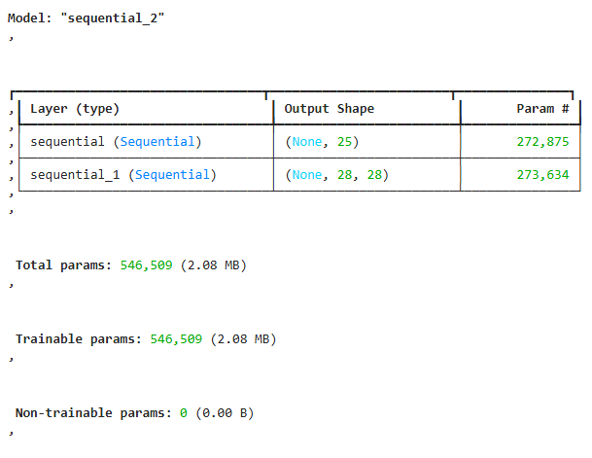

CNN AutoEncoder

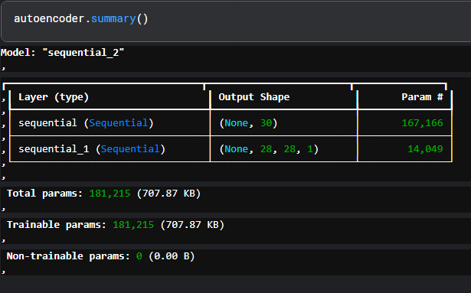

Code of autoencoder.fit()

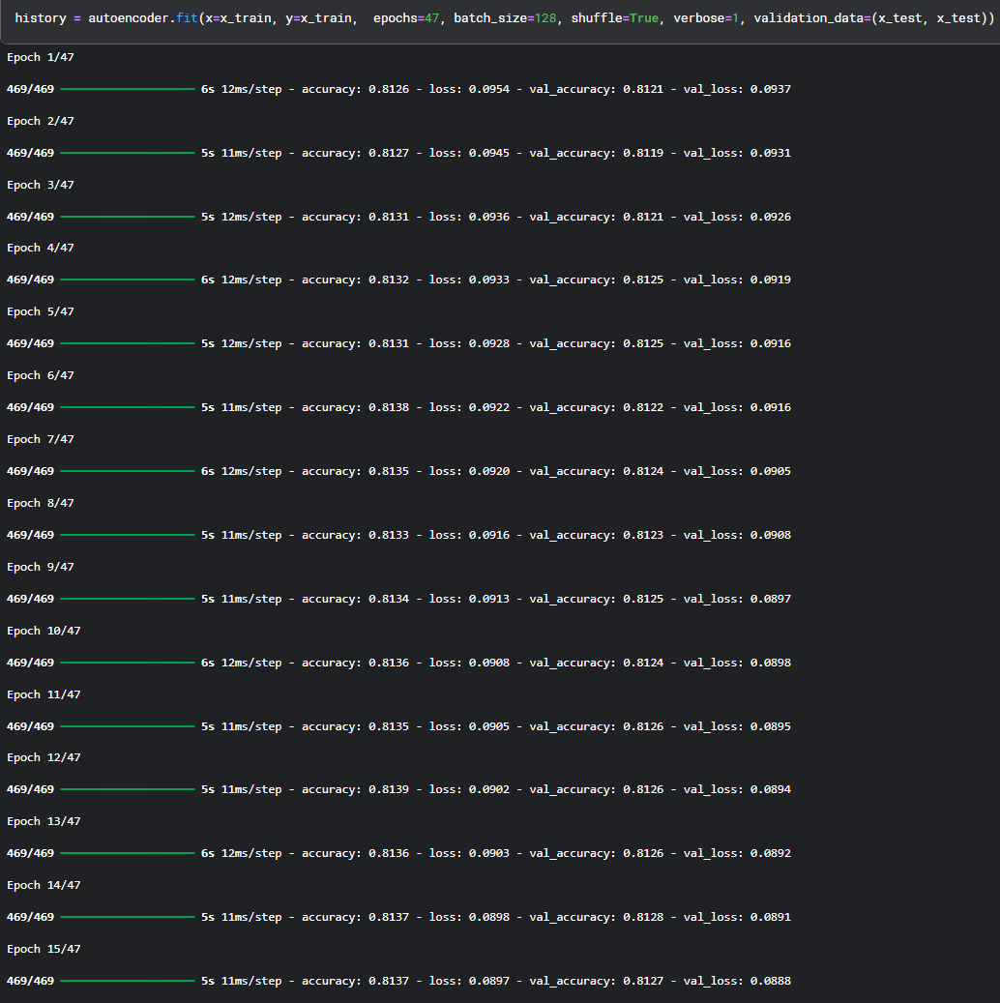

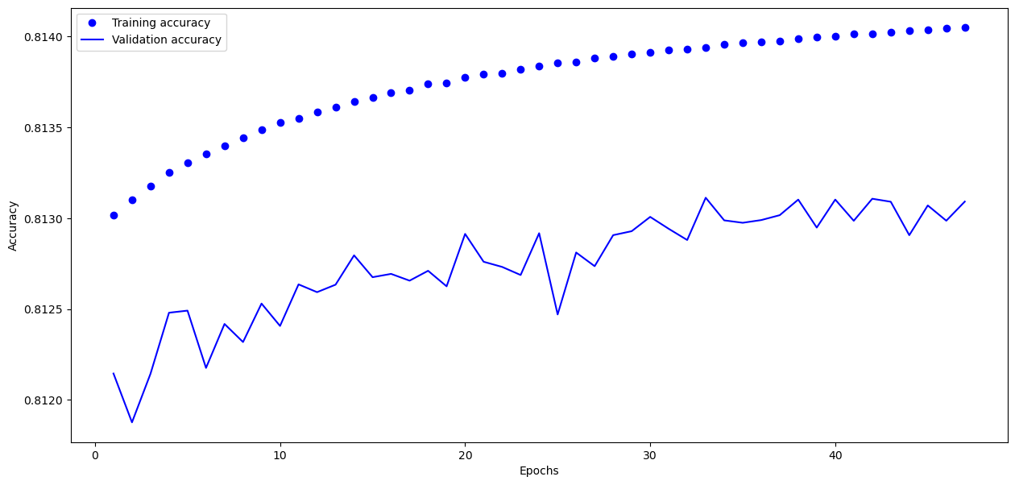

Lab 11

Lab 12

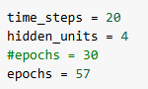



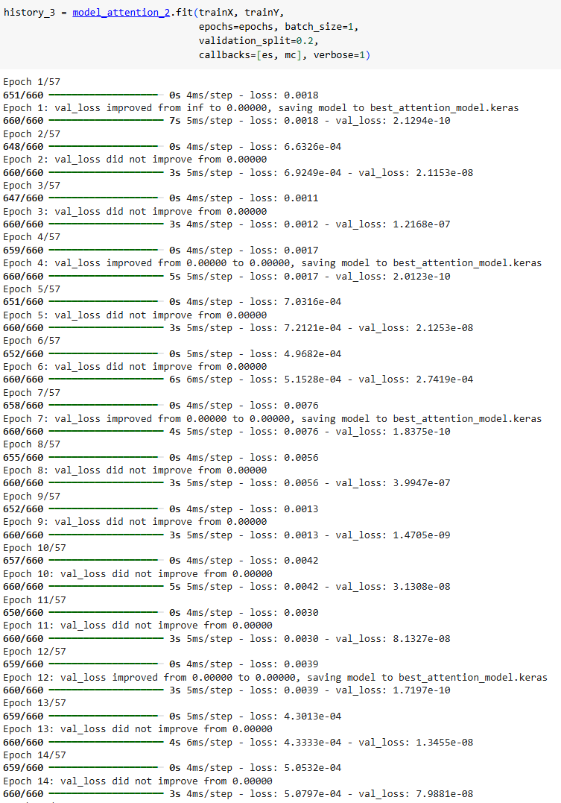

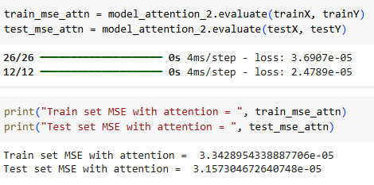

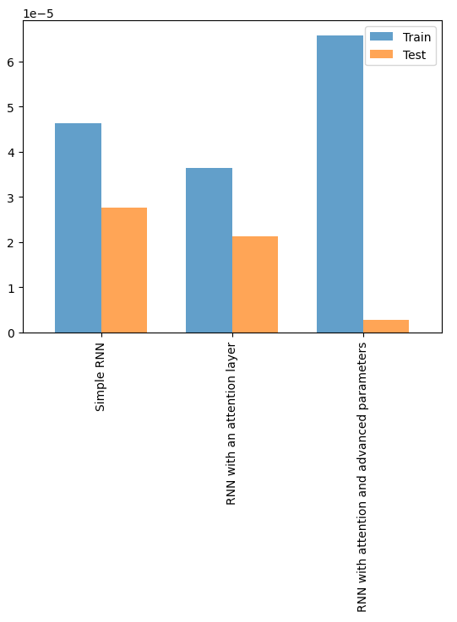

Github Link: https://github.com/APJ-Aswin-Porkodiyaan-Jeyaraj/Deep-Learning-and-Neural-Netwoks